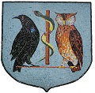
RAMSEY GROUP PRACTICE LLC
BANK HOLIDAY CLOSURES

MONDAY 1ST MAY 2023
MONDAY 8TH MAY 2023
MONDAY 29TH MAY 2023
In the event of a life threatening illness please dial 999
If you have an issue that cannot wait until the Ramsey Group Practice is open again please ring
MEDS on 650355

